Questions from the CHM webinar

- How does the Grad Plus loan work as part of my package?
The Grad Plus is used to supplement your educational cost if the
unsubsidized loans are not enough to cover your expenses.

- Where to I apply for a short-term loan? You will apply for your loan at student.msu.edu.
Then, click “student accounts”. You will then click “MSU loans”. Next, you will click on the “Financial Aid” drop down menu at the top right and then “Short Term Loan application”.
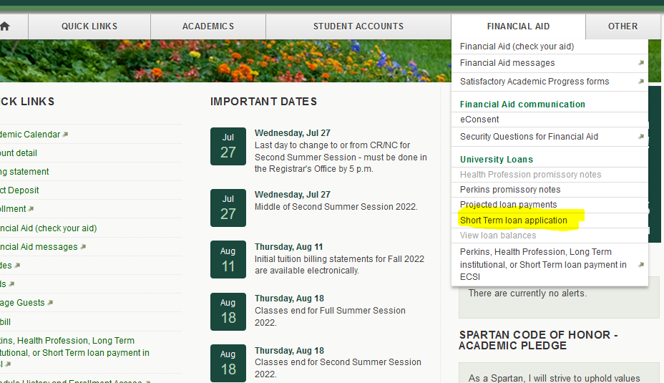

- When will I have access on the portal to apply for a short-term loan? Once you are enrolled in classes, you should be able to access the link to apply.

- When do I need to pay back the loan? You will need to pay the loan within 60 days with your forthcoming refund.

- What is the interest for the short-term loan?
It is 7% annually or about 1% for the 60 day period.

- What are the origination fees for loans? The origination fees are 1.057% for Stafford (Direct Loans) and 4.228% for GradPlus.

- Where do I go to accept my loans? You will accept your loans
by logging into your financial aid portal.

- Can I schedule an appointment to meet with a financial aid advisor? Yes,
we have staff available to meet with you via a walk-in, scheduling a call, or
a Zoom meeting.

- Do I use my refund to repay my short-term loan? Yes, you are
to use your refund monies to pay back your short-term loan.

- Are grant scholarships awarded? Yes, they are primarily awarded through
your college when you are admitted. Please check with your college for
additional information.

- How will I pay for my bill prior to receiving financial aid? If you have applied for and accepted your aid package, student accounts is aware of your anticipated aid and this information will be noted in the system and your payment will be processed.

